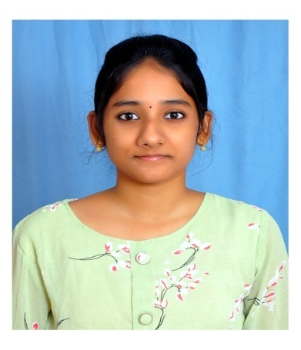**PRAVALIKA MUDIREDDY**

**Address:** Bhavanipuram,Vijayawada, Andhra Pradesh

**Mobile No.:** +91-7075202136

**Email:** pravallikamudireddy@gmail.com

**D.O.B:** 23/05/2002

**Branch/Stream:** Computer Science and Engineering.

**Career Objective:**

To Secure a Challenging Position where I can fully utilize my skills and knowledge by contributing the best for the growth of the Organization while ensuring growth in my career.

**Academic Details:**

•          PSCMR College of Engineering and Technology,Vijayawada            January 2021-2024

             Present Pursuing 3rd year,                             CGPA: 7.83(Till 3-1)

             Department of Computer Science and Engineering

•          Sri Gayatri junior college , Gollapudi                                    June 2018-2020

             Board of Intermediate Education AP          GPA: 7.53

             MPC

•          Sri Chaitanya Techno school ,Bhavanipuram         June 2017-2018

School of Secondary Education                 GPA: 9.7

**Achievements:**

• I am a Python 3.x Programmer **(core)**

• I am always in the top 5 of my Branch.

**Technical Skills:**

• Programming Language: Python, C, C++ , Java (Basics)

• Database: SQL

• Data Structures

• Web Technologies: HTML, Javascript

**Online Courses/Certifications:**

* Certified in Python for beginners course by SOLOLEARN .
* Certified in C, C++ , HTML, Responsive web design, courses by SOLOLEARN.
* Certified for successfully completing the course “Google Tag Manager Fundamentals”, “Google Analytics for beginners”, in Google Analytics Academy.
* Certified for successfully completing the course “Introduction to Agile methodology” in Infosys - October 2022
* Certified in TCS-ION career edge-young professional in tcs-ion - January 2022.
* Certified in Problem Solving course by Hacker Rank - September 2022.

**Internship :**

I have done my internship Based on Machine Learning At “Indian Servers” Company    , Vijayawada. I did my project Dog Breed Classification Using Convolutional Neural Network  as a part of my internship.Duration of my internship is 2 months(June-August).

**Project :**

●          In my  Second year-Second  semester. Me & My team members did a mini IOT project together.Project Aim is Distance Measurement using Ultrasonic Sensor. Project name is Arduino Ultrasonic distance Alarm.

●         I did a project named Dog breed identification using CNN in the domain of machine learning as a part of my internship.

**Co-curricular Activities:**

* Participated in a 1 Hour Workshop on “Power Python”. - March 2022.
* Participated and Certified for successfully completed the gaining knowledge weekly event conducted by Computer Science and Engineering.
* Participated in Online Technical Quiz on “Python” by Swecha.
* Participated and Certified for attending webinar on “Career Building with Upskillz”. - July 2022

**Extra-curricular Activities:**

* Volunteer in Women Empowerment and Champion Campaign – Bhumi ( March and April 2021)
* Volunteer in National Service Scheme - NSS January 2020 - Present
* Participating in different social service activities as a Volunteer from PSCMR NSS unit.

PSCMR SLC October 2021 - Present.

**Declaration:**

I, with this, declare that the above information provided is true and correct to the best of my  knowledge.

**Place:** Vijayawada **Signature:**

**Date:** M Pravalika